Name: Nicholas Smith
Subject: Web programming
Lecture: Mrs.Badhika
School of Computing and Information Technology
Web Programming (CIT2011)
Semester 1 AY 25-26

Hosting link: nicholas-2106718.github.io/2106718_web_programming_IA-2/
Repository link: Nicholas-2106718/2106718_web_programming_IA-2
Description:
Omni-Mart is a e-business that mainly sells furniture (beds, sofas, chairs), house hold appliances (vacuums, fans, TVs) and electronic devices (computers, printers, laptops).
Slogan:
"Everything you need, anywhere you are."
Mission Statement:
To provide customers with high-quality, affordable furniture, household appliances, and electronic devices through a seamless online shopping experience, ensuring satisfaction and convenience at every step.
Vision:
To become the leading online destination for home essentials and electronics, redefining shopping convenience and inspiring comfortable, modern living for families everywhere.
Target Audience:
Omni-Mart's target audience includes homeowners, professionals and families seeking convenient access to quality furniture, household appliances, and electronic devices.

Page Layouts:
Index.html:
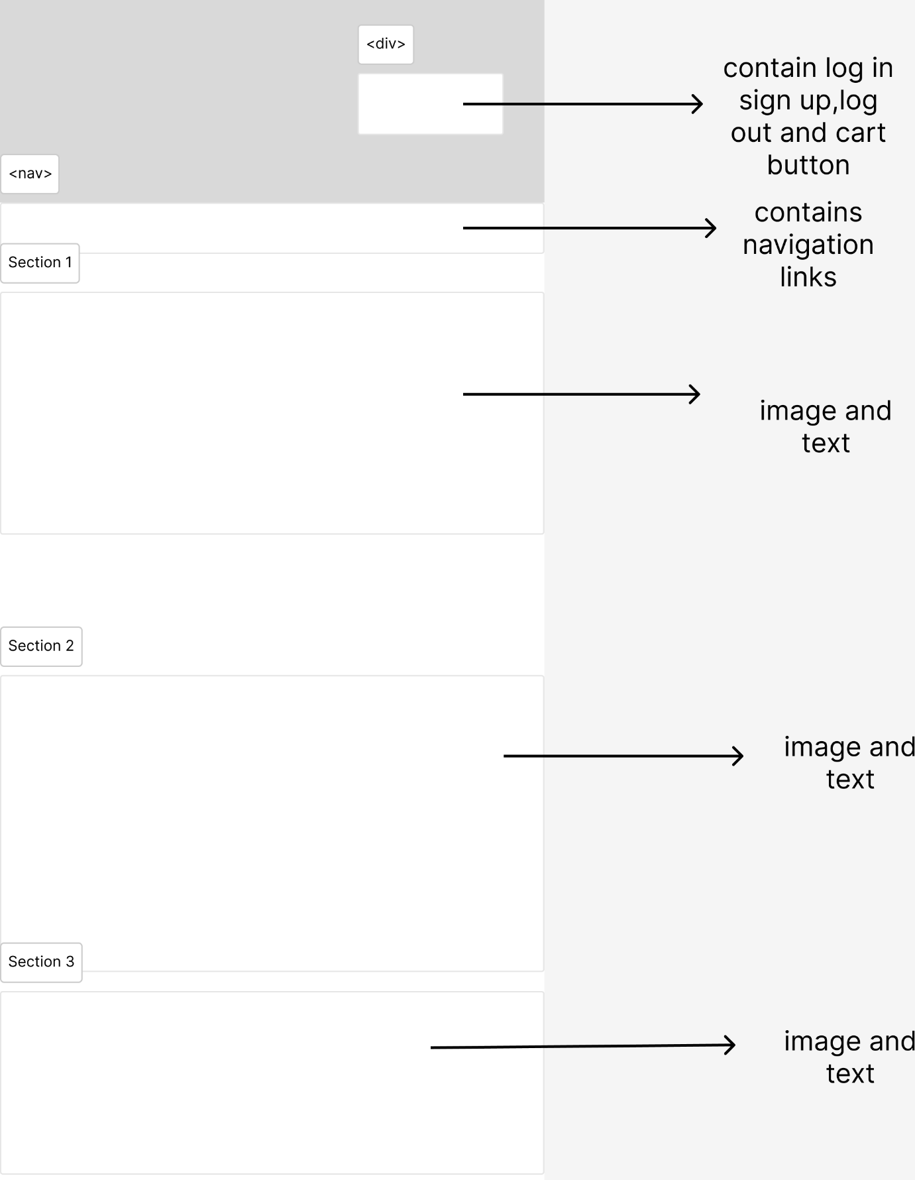

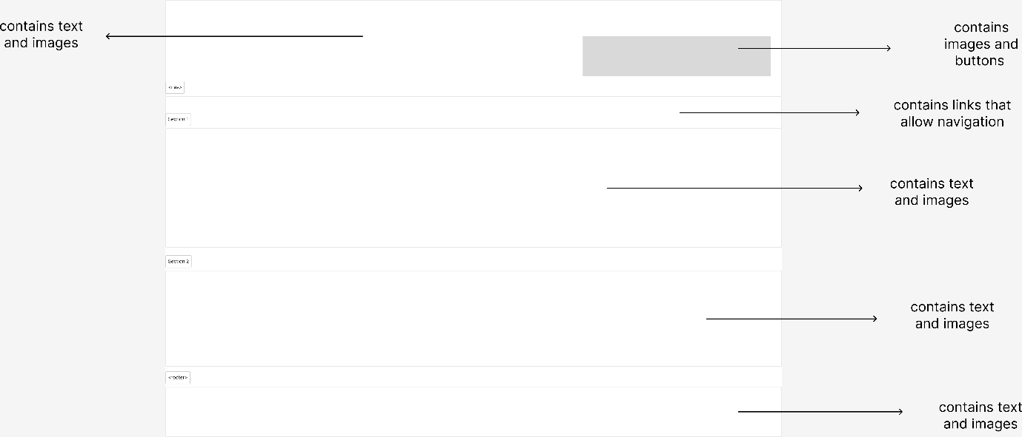
This is the homepage for Omni-Mart. It features a header with navigation options for signing in, signing up, and viewing the shopping cart. The page showcases images and highlights the store's offerings and encouraging users to create an account for a better shopping experience.

Furniture.html:
desktop
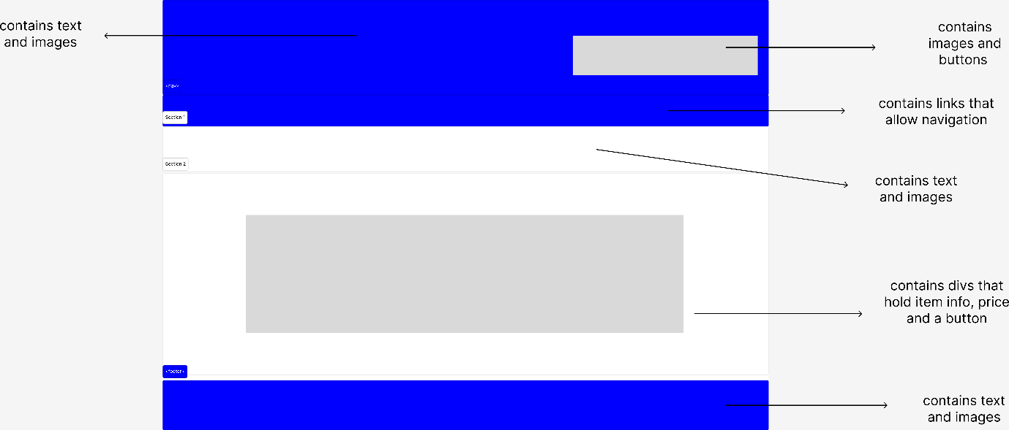

mobile
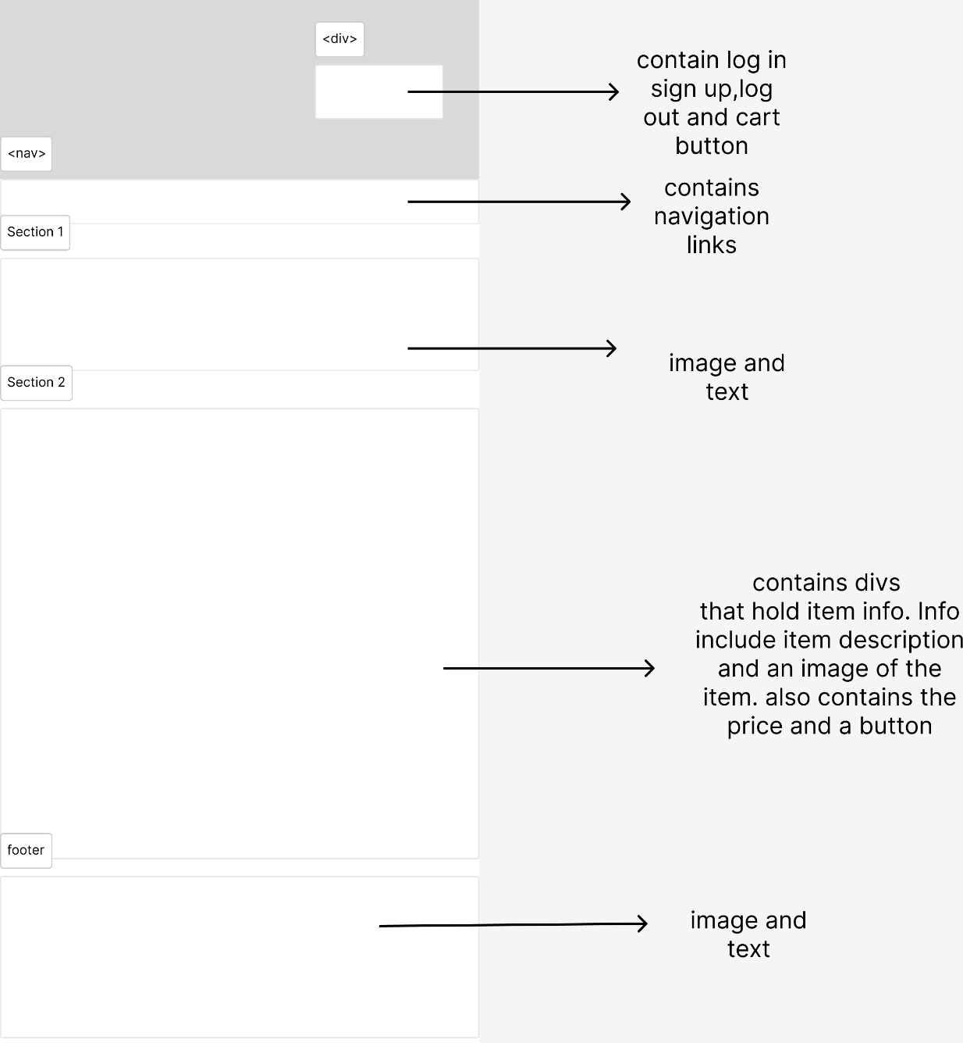
This page showcases furniture items with images, descriptions, and prices, encouraging visitors to browse and add products to their shopping cart.

Electronics:
desktop

mobile
This page showcases electronic items with images, descriptions, and prices, encouraging visitors to browse and add products to their shopping cart.

Appliances:
desktop

mobile
This page showcases appliances with images, descriptions, and prices, encouraging visitors to browse and add products to their shopping cart.

Signin.html:
Mobile
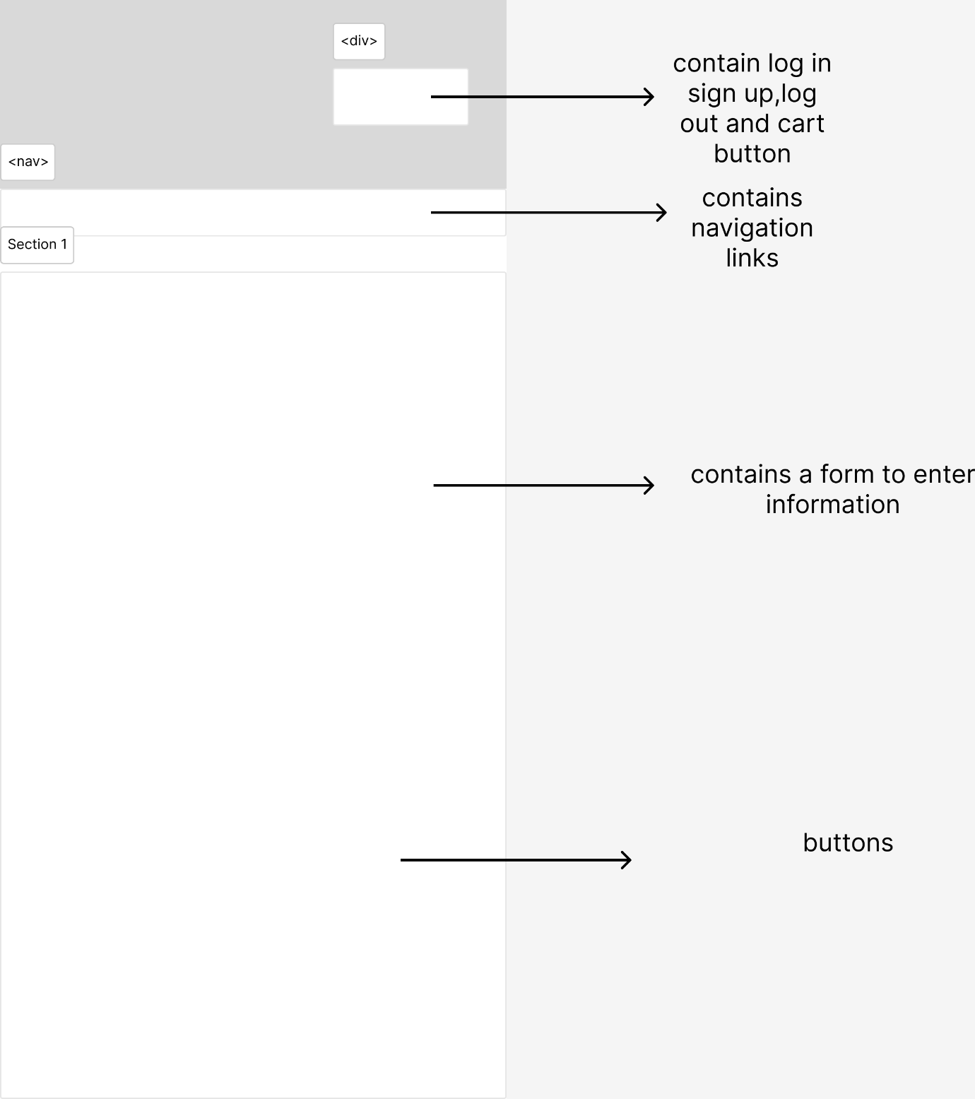

Desktop
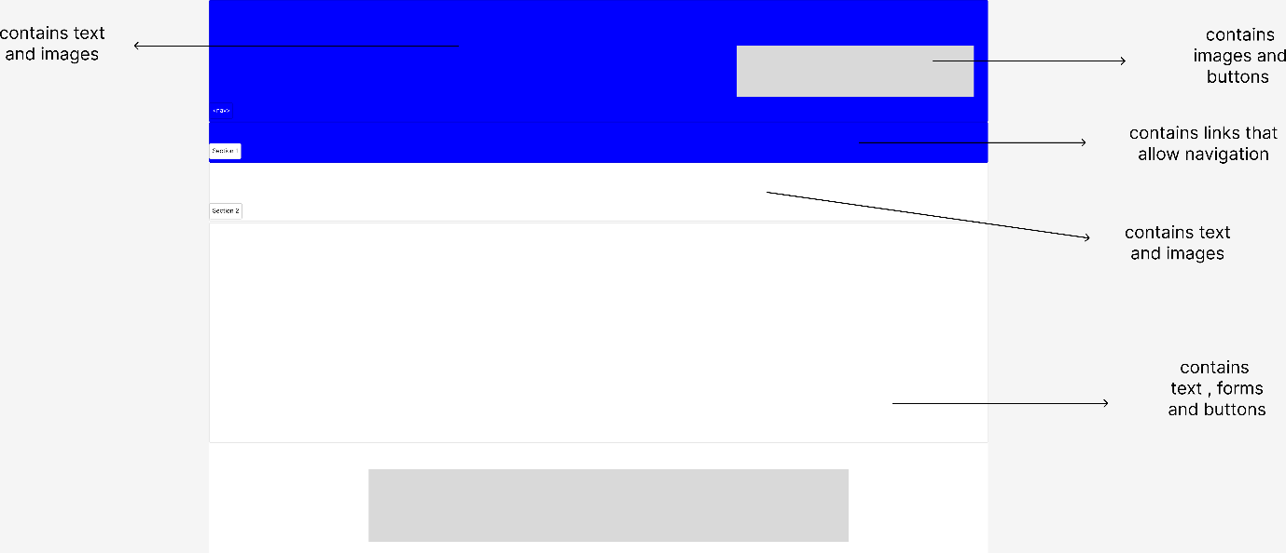
This page is the login interface for the “Omni-Mart" website. It allows users to log in via forms and buttons. It includes a header with the site name, user account icons, and a cart icon that links to the shopping cart page.

Signup.html:
Mobile

Desktop
This page is the registration form for the "Omni-Mart" website. includes a form where new users can input their email, password, name, and telephone number to register.

Cart.html:
Mobile
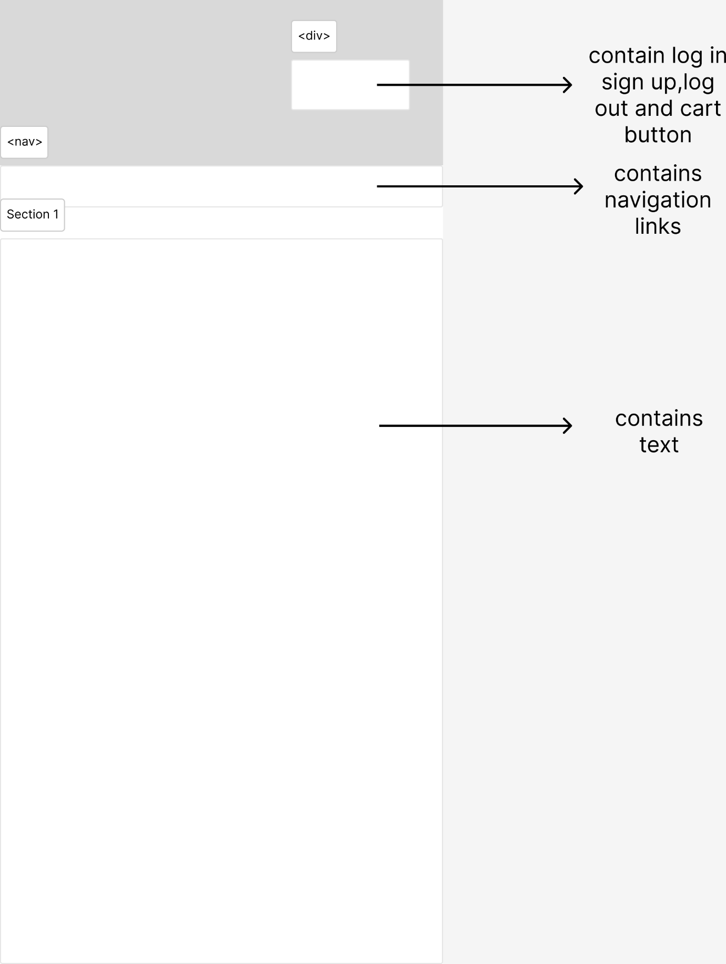

Desktop
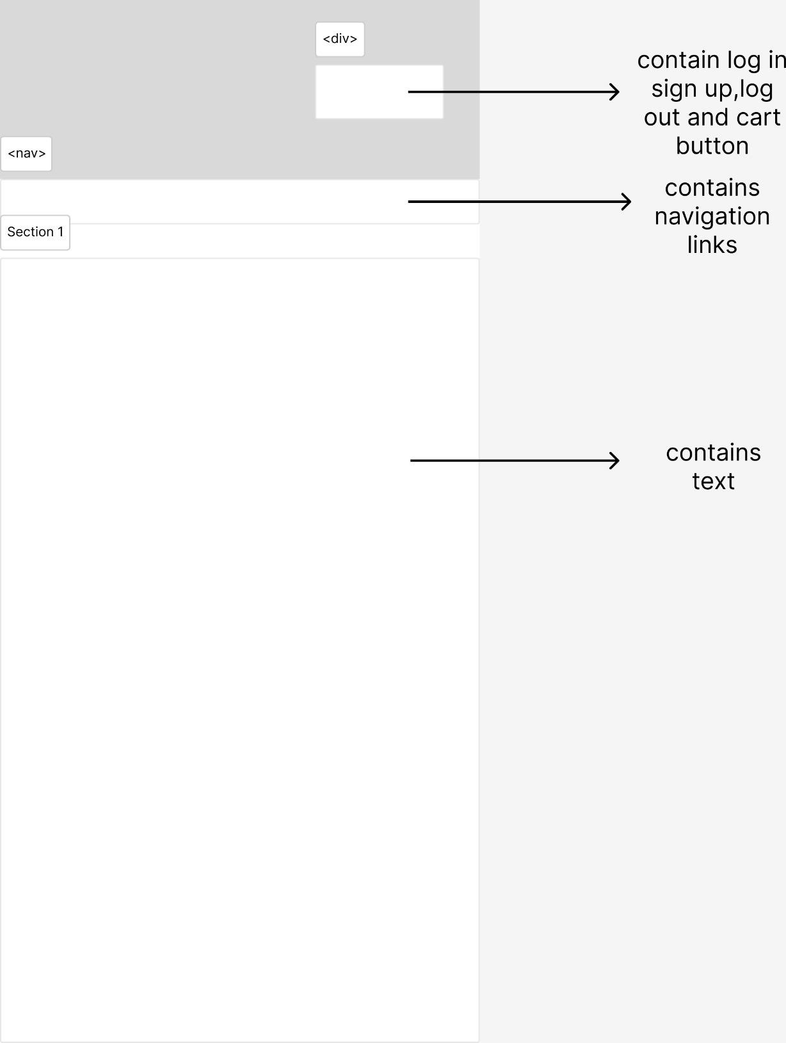
This page shows the shopping cart for Omni-Mart website. The main features and two buttons: one to clear the cart and another to proceed to checkout.

Checkout.html
Mobile

desktop
This page is a checkout form for Omni-Mart. It prompts users to enter their delivery address and payment details to complete their purchase.

Colour palette:

Blue: RGB (0, 0, 255)

White: RGB (255, 255, 255)
I chose a blue and white colour scheme since it represents trust, reliability, and professionalism. Blue is linked to stability and calmness, which helps customers feel safe while shopping online. White offers a clean, simple background that improves readability. Combined, these colours foster a trustworthy and user-friendly atmosphere, motivating customers to explore and shop with confidence.

Icons used:
https://www.pngwing.com/en/free-png-nwlnf
dimensions 1312 x 1302



https://www.hiclipart.com/free-transparent-background-png-clipart-mepgu
dimensions: 748 x 748



Font Info:
- Franklin Gothic Medium
- Arial Narrow
- Arial
- sans-serif

the font weight being used is the default ‘400’

JavaScript Functions:
function add_cart(): allows user to add item to cart, so it may show up on cart.html.
function clearcart(): allows users to delete all items added via add_cart function.
function cartgen(): function to print the item names and price onto the cart html.
function checklogin() : validates whether the user is logged in or not.
function signin(): function to allow users to log in,
function logout(): function to log out users,
function checkoutclick(): function to validate entries and to do the checkout process
function signup(): function to allow users to create an account.
function valemail(email): function to validate if email is in the correct format.
function valemail(telephone) : function to validate if email is in the correct format.

Links to Images used:

1. Index Page (Home)
- Alamy - Kitchen & Household Appliances
- Lampman Furniture Gallery
- Room & Board - Dining & Kitchen Table & Chair Pairings
- Shutterstock - Living Room Sofa & Bookcase

2. Furniture Page
- Overstock - Wooden Dining Table
- Living Spaces - Annaliese Dark Grey Sofa
- Lowe’s - Clovis King Panel Bed in Grey

3. Electronic Page
- Ubuy - Dell Optiplex 7040 Desktop
- HP - Business Printers
- Best Buy - HP Omnibook X Flip 2-in-1 Laptop

4. Appliances Page
- Amazon Australia - Panasonic Microwave
- Amazon US - Samsung 4-Door Refrigerator
- Courts Jamaica - Mabe Stove with Double Oven

References:
GeeksforGeeks. (n.d.). JavaScript tutorial. https://www.geeksforgeeks.org/javascript/javascript-tutorial/
W3Schools. (n.d.). W3Schools online web tutorials. https://w3schools.com
Stack Overflow. (n.d.). Stack Overflow. https://stackoverflow.com
YouTube. (n.d.). YouTube. https://youtube.com
GeeksforGeeks. (n.d.). JavaScript program to validate an email address. https://www.geeksforgeeks.org/javascript/javascript-program-to-validate-an-email-address/
GeeksforGeeks. (n.d.). How to insert a row in an HTML table in JavaScript. https://www.geeksforgeeks.org/html/how-to-insert-a-row-in-an-html-table-in-javascript/
Overstock. (n.d.). YAT ANA T wooden dining table rectangular table top surface with 4 table legs natural finish finish option 1 table. https://www.overstock.com/Home-Garden/YAT-ANA-T-Wooden-Dining-Table-Rectangular-Table-Top-Surface-with-4-Table-Legs-Natural-Finish-Finish-Option-1-Table/32691823/product.html?kwds=&rfmt=brand%3AEast+West+Furniture
Living Spaces. (n.d.). Annaliese dark grey sofa. https://www.livingspaces.com/pdp-annaliese-dark-grey-sofa-383665
Lowe’s. (n.d.). Picket House Furnishings Clovis king panel bed in grey. https://www.lowes.com/pd/Picket-House-Furnishings-Picket-House-Furnishings-Clovis-King-Panel-Bed-in-Grey/5001666701
Electronics
Ubuy. (n.d.). Dell Optiplex 7040 desktop computer PC intel quad-core i5 2TB HDD 8GB DDR3 RAM Windows 10 Pro DVD Wi-Fi 19in monitor USB keyboard and mouse. https://www.ubuy.com.jm/product/4Y2AMQOMG-dell-optiplex-7040-desktop-computer-pc-intel-quad-core-i5-2tb-hdd-8gb-ddr3-ram-windows-10-pro-dvd-wifi-19in-monitor-usb-keyboard-and-mouse
Best Buy. (n.d.). HP Omnibook X Flip 2-in-1 copilot PC 14.2K touch screen laptop AMD Ryzen AI 5 16GB memory 512GB SSD Meteor Silver. https://www.bestbuy.com/product/hp-omnibook-x-flip-2-in-1-copilot-pc-14-2k-touch-screen-laptop-amd-ryzen-ai-5-16gb-memory-512gb-ssd-meteor-silver/JJGQJRKGHK
Appliances
Amazon Australia. (n.d.). Panasonic NN-CD58JSQPQ microwave stainless steel. https://www.amazon.com.au/Panasonic-NN-CD58JSQPQ-Microwave-Stainless-Steel/dp/B085TMMJZN
Amazon US. (n.d.). Samsung capacity 4-door refrigerator stainless. https://us.amazon.com/SAMSUNG-Capacity-4-Door-Refrigerator-Stainless/dp/B0CH21KFYV
Courts Jamaica. (n.d.). Mabe IO950TS0 air fry double oven black stove. https://www.courts.com/jamaica/stove-mabe-io950ts0-air-fry-double-oven-black-322187/p

